**FOUNDATION OF DATA SCIENCE**

**ASSIGNMENT - 2**

**MUSIC RECOMMENDATION SYSTEM**

**OUTPUT**

Graph:

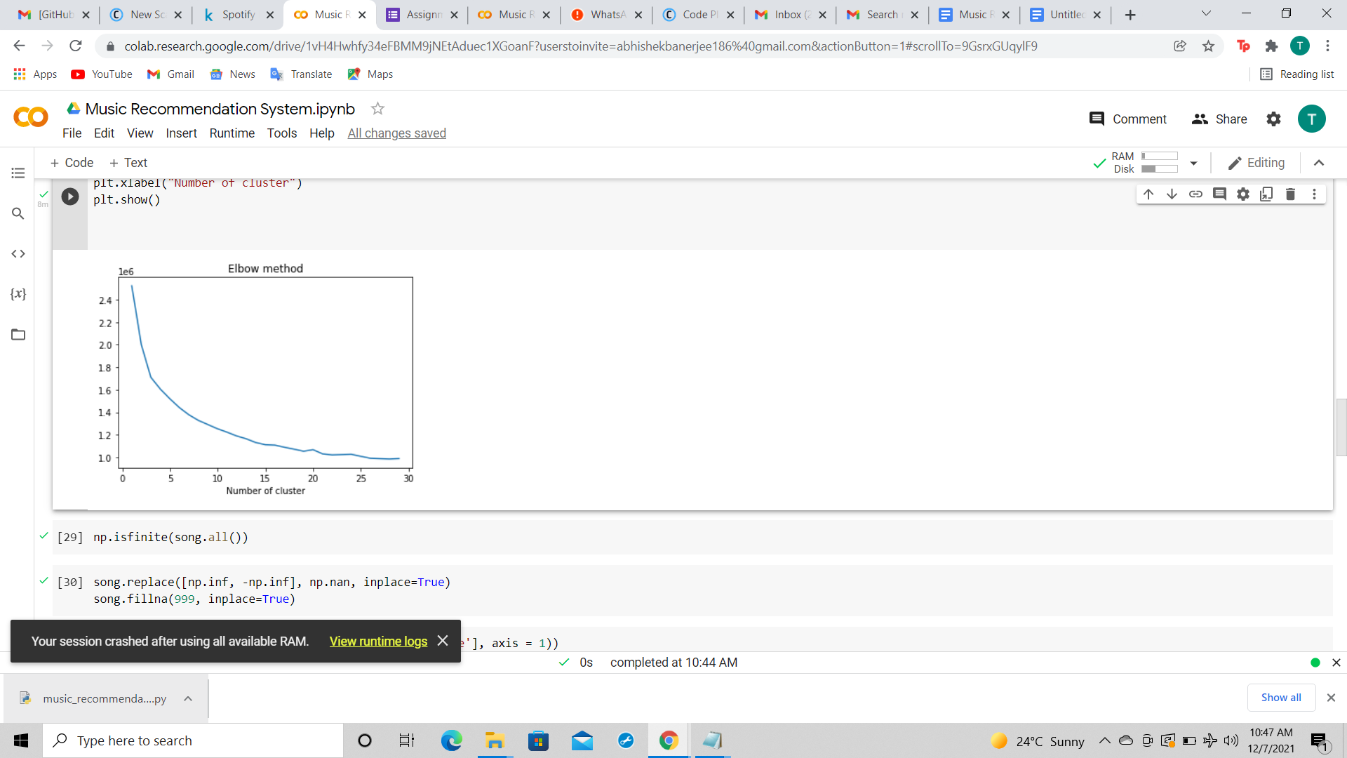

Output:

